# DFD for Driving School

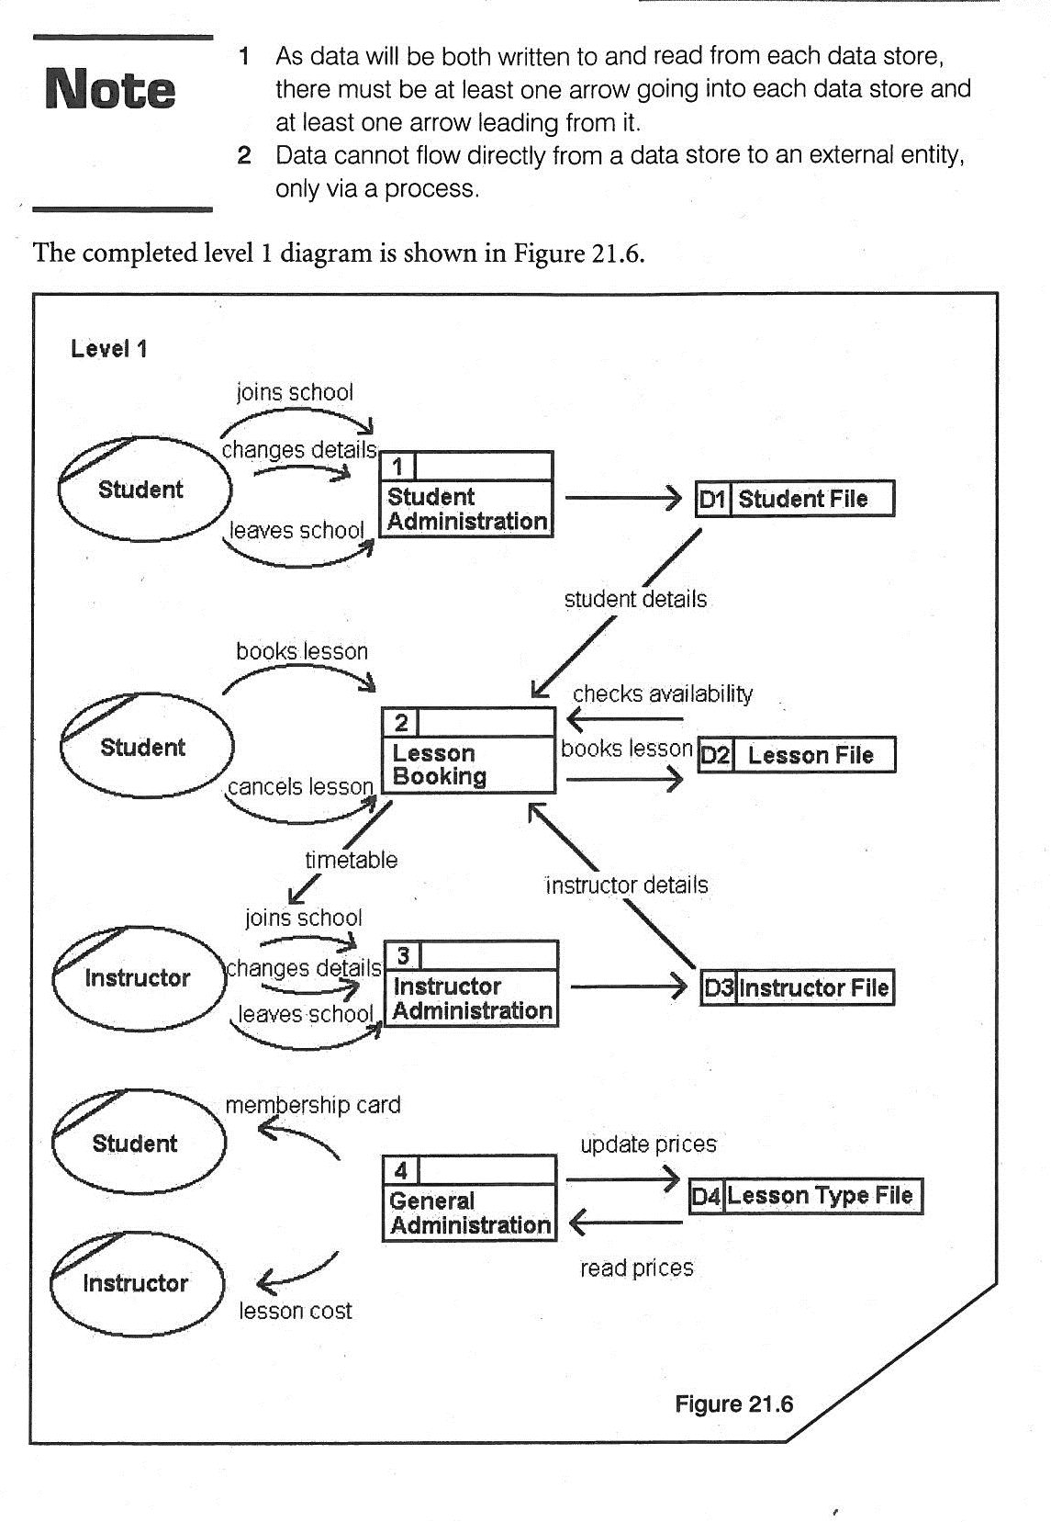This DFD is drawn by showing all the processes separately and how there are flows of data to and from external entities and data stores (databases).